[root@ds-asterisk-str01p ~]# systemctl status commvault
● commvault.service - CommVault Service
Loaded: loaded (/etc/systemd/system/commvault.service; enabled; vendor preset: disabled)
Active: inactive (dead)
[root@ds-asterisk-str01p ~]#

[root@ds-asterisk-str01p ~]# /opt/simpana/installer/cvpkgrm

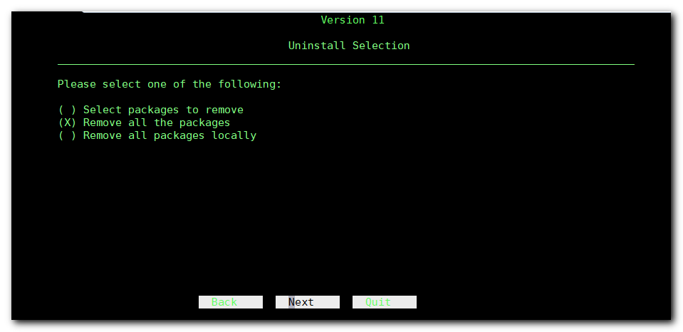
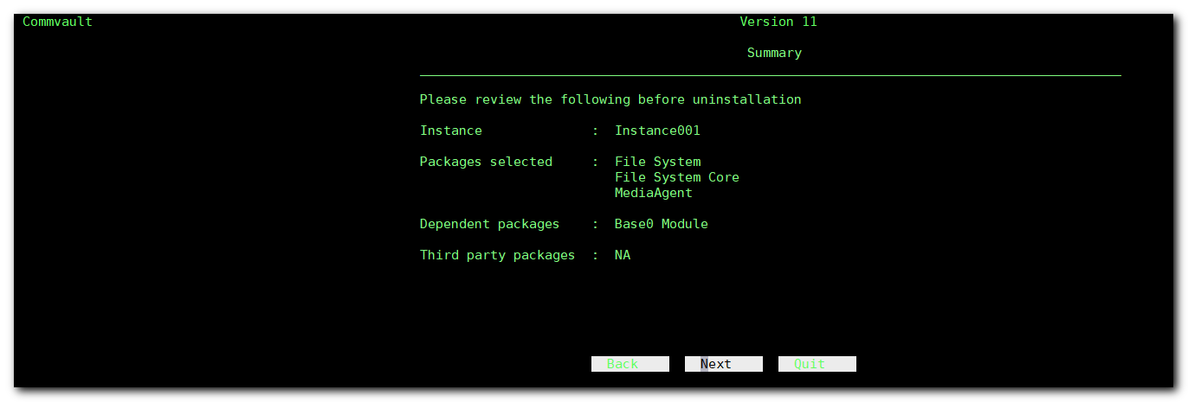
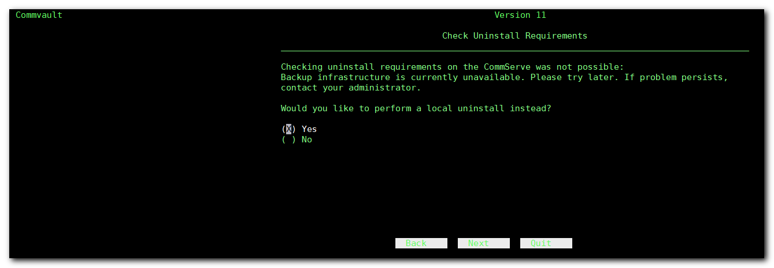
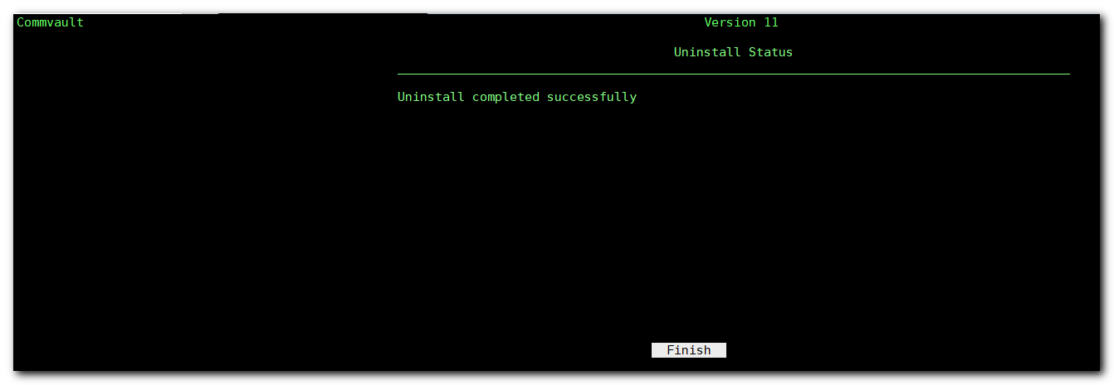
[root@ds-asterisk-str01p ~]# /opt/simpana/installer/cvpkgrm

~~~ Instance001 11.0.0 @/opt/simpana ~~~

Using installer /opt/simpana/installer/newinstall:
- v1180382 10793KB gzipped at uslinux01 on 17-09-13 11:07:09 by pbuilder
Preparing .. READY.

EXTRACT_DIR = /opt/.gxsetup/cvpkgrm
[root@ds-asterisk-str01p ~]#

[root@m1-asterisk-str01p ~]# systemctl status simpana
● Galaxy.service - LSB: Data Recovery Service
Loaded: loaded (/etc/rc.d/init.d/Galaxy; bad; vendor preset: disabled)
Active: active (exited) since Wed 2019-03-06 14:36:42 MSK; 4 months 4 days ago
Docs: man:systemd-sysv-generator(8)

Mar 06 14:36:37 m1-asterisk-str01p.tcsbank.ru systemd[1]: Starting LSB: Data Recovery Service...
Mar 06 14:36:37 m1-asterisk-str01p.tcsbank.ru Galaxy[2838]: Cleaning up /opt/simpana/Base/Temp ...
Mar 06 14:36:37 m1-asterisk-str01p.tcsbank.ru Galaxy[2838]: Starting Simpana services for Instance001 ...
Mar 06 14:36:42 m1-asterisk-str01p.tcsbank.ru systemd[1]: Started LSB: Data Recovery Service.
[root@m1-asterisk-str01p ~]# systemctl stop simpana
[root@m1-asterisk-str01p ~]#

/opt/simpana/installer/cvpkgrm

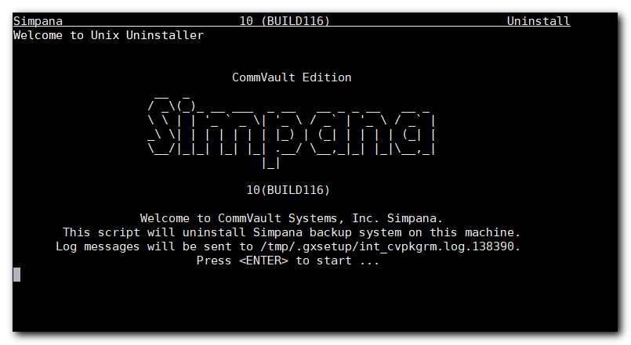
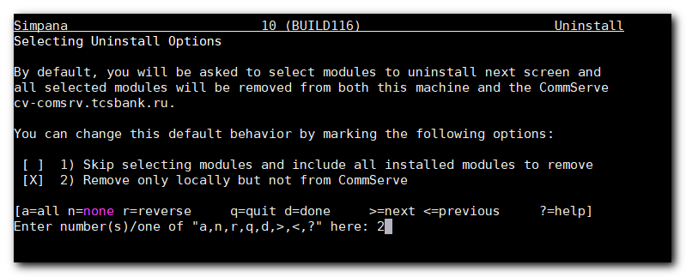
#
# Was selected both 1. and 2. points.
# To appy - was entered “d” and “Enger” button.

Simpana 10 (BUILD116) Uninstall
Performing Final Cleanup

Instance001

Removing all packages and updates under /opt/simpana ... done.
Removing all registry under Galaxy/Instance001 ... done.

Thank you for using CommVault Systems, Inc. Simpana...

[LOG INFO] To review the setup, you may find the following logs useful if available:
(1) logs under /tmp/.gxsetup
(2) install.log|env and UpdateInfo.log|env under Log Directory
(3) logs under /var/log/.gxsetup/<time>_<program>_10-116-m1-asterisk-str01p.tcsbank.ru-10.216.107.100-138390[_f]
(4) logs under (User home directory)/.gxsetup/<time>_<program>_10-116-m1-asterisk-str01p.tcsbank.ru-10.216.107.100-138390[_f]
dirname: missing operand
Try 'dirname --help' for more information.
[root@m1-asterisk-str01p ~]#

[s.belogrud@TCS4357]# git --no-pager log -n 1 -p site/role/manifests/asterisk_str.pp
commit d8c3af74c1f9d6f1f3ebc0091759d297c13a6065 (HEAD -> 20190711_SD2872032, origin/20190711_SD2872032)
Author: Sergey Belogrud <s.belogrud@tinkoff.ru>
Date: Thu Jul 11 12:10:15 2019 +0300

SD#2872032. Was added simpana agent installation.

diff --git a/site/role/manifests/asterisk_str.pp b/site/role/manifests/asterisk_str.pp
index 7fa073ae..b77c1e53 100644
--- a/site/role/manifests/asterisk_str.pp
+++ b/site/role/manifests/asterisk_str.pp
@@ -1,5 +1,6 @@
class role::asterisk_str {
include profile::base
+ include profile::simpana::install
include profile::accounts::vov
include profile::accounts::e_pinashin
}
[s.belogrud@TCS4357]#

[root@ds-asterisk-str01p ~]# puppet agent -t
Info: Using configured environment 'production'
Info: Retrieving pluginfacts
Info: Retrieving plugin
Info: Loading facts
Info: Caching catalog for ds-asterisk-str01p.tcsbank.ru
Info: Applying configuration version 'vm-puppetmaster02p.tcsbank.ru-production-d4449c17a26'
Notice: /Stage[main]/Profile::Simpana::Install/Exec[get_archive]/returns: executed successfully
Notice: /Stage[main]/Profile::Simpana::Install/Exec[extract_archive]/returns: executed successfully
Error: Command exceeded timeout
Error: /Stage[main]/Profile::Simpana::Install/Exec[install_simpana_agent]/returns: change from 'notrun' to ['0'] failed: Command exceeded timeout
Info: Class[Profile::Simpana::Install]: Unscheduling all events on Class[Profile::Simpana::Install]
Notice: Applied catalog in 309.04 seconds
[root@ds-asterisk-str01p ~]#

[root@ds-asterisk-str01p ~]# systemctl status simpana
Unit simpana.service could not be found.
[root@ds-asterisk-str01p ~]# systemctl status commvault
● Galaxy.service - LSB: Data Recovery Service
Loaded: loaded (/etc/rc.d/init.d/Galaxy; bad; vendor preset: disabled)
Active: active (exited) since Thu 2017-06-08 11:50:47 MSK; 2 years 1 months ago
Docs: man:systemd-sysv-generator(8)

Jun 08 11:50:44 ds-asterisk-str01p.tcsbank.ru systemd[1]: Starting LSB: Data Recovery Service...
Jun 08 11:50:44 ds-asterisk-str01p.tcsbank.ru Galaxy[2794]: Cleaning up /opt/simpana/Base/Temp ...
Jun 08 11:50:44 ds-asterisk-str01p.tcsbank.ru Galaxy[2794]: Starting Simpana services for Instance001 ...
Jun 08 11:50:47 ds-asterisk-str01p.tcsbank.ru systemd[1]: Started LSB: Data Recovery Service.
[root@ds-asterisk-str01p ~]#

[root@ds-asterisk-str01p ~]# /opt/commvault/Base/simpana -list

*** Instance001, cv-comsrv ***
+-----------+---------+--------------------------------------------------------+
| Service | PID | Description |
+-----------+---------+--------------------------------------------------------+
| cvlaunchd | N/A | Commvault Launch Daemon |
+-----------+---------+--------------------------------------------------------+
| cvd | N/A | Commvault Communications Service |
+-----------+---------+--------------------------------------------------------+
| ClMgrS | N/A | Commvault Client Event Manager |
+-----------+---------+--------------------------------------------------------+
| cvfwd | N/A | Commvault FireWall Daemon |
+-----------+---------+--------------------------------------------------------+
[root@ds-asterisk-str01p ~]#

